**Reactions of Organic Compounds**

**Addition reactions** are organic reactions that occur when atoms are added across the double bond of an unsaturated molecule.

**Hydrogenation** Alkene + Hydrogen Gas ($H_{2}$) $\underset{→}{metal catalyst such as Pt}$ Alkane

For alkynes, hydrogenation proceeds in a stepwise fashion, forming an alkene first, which undergoes further hydrogenation to an alkane. This reaction proceeds so smoothly that it is difficult, if not impossible, to stop the reaction at the alkene stage.

**Halogenation** Alkene + Bromine (${Br}_{2}$) / Chlorine (${Cl}_{2}$) → Haloalkane (no heat or catalyst needed)

The addition of halogens to an alkyne proceeds in the same manner as halogen addition to alkenes. The halogen atoms add to an alkyne molecule in a stepwise fashion, leading to the formation of the corresponding alkene, which undergoes further reaction to a tetrahaloalkane.

**Chemical Test** to distinguish Alkanes from Alkenes and Alkynes – If bromine water (bright orange) added to alkane = no colour change, but bromine water added to alkene or alkyne goes clear.

**Hydrohalogenation** Alkene + Hydrogen Halide (Inorganic acids) → Haloalkane (no heat or catalyst needed)

Hydrogen halides react with alkynes in the same manner as they do with alkenes.

**Hydration** of Alkenes addition of water to an alkene (across the double bond) in the presence of a catalytic amount of strong acid leads to the formation of alcohols **Alkene + Water $\underset{→}{High Temp, high pressure, strong acid}$ Alcohol**

The addition of the elements of water across the triple bond of an alkyne leads to the formation of aldehydes and ketones. Water addition to terminal alkynes leads to the generation of **aldehydes**, while nonterminal alkynes and water generate **ketones.**

**Polymerisation** Self-addition reaction of alkene monomers – the polymer is named from the monomer

An **elimination reaction** occurs when a single reactant splits into two products. In a sense, it is opposite of addition reactions. In other words removing substituents to form a multiple bond. Most commonly with a haloalkane.

Haloalkane + NaOH $\underset{→}{High Temperature}$ Alkene + Salt + Water

**Dehydration** Alcohol $\underset{→}{Strong acid H_{2}{SO}_{4}}$ Alkene + Water

A **substitution reaction** is an organic reaction that occurs when an atom or functional group in a molecule is replaced or substituted by another atom or group.

**Substitution of Alkanes** Alkane + Halogen $\underset{→}{UV light}$ Haloalkane + Hydrogen Halide

**Substitution of Alcohols** Alcohol + Hydrogen Halide → Haloalkane + Water

**Substitution of Haloalkanes** Haloalkane + Sodium / Potassium Hydroxide → Alcohol + Metal Halide

A **hydrolysis reaction** is an organic chemical reaction which involves the breaking of a chemical bond by the addition of water

* Saponification Ester + Sodium Hydroxide → Sodium Carboxylate + Alcohol

**Oxidation reactions** involve a transfer of electrons from one reactant to another. In organic chemistry, oxidation refers to loss or gain of electrons by carbon.

Alkenes can easily be oxidized by potassium permanganate and other oxidizing agents. What products form depend on the reaction conditions.

Alkynes are oxidized by the same reagents that oxidize alkenes

The products of **alcohol oxidation** depend on the type of alcohol reacted and the reaction conditions

**Primary alcohols** are oxidized stepwise to first produce aldehydes then carboxylic acids

**Secondary alcohols** are oxidized to produce ketones

**Tertiary alcohols** cannot be oxidized

**Combustion** of hydrocarbons and alcohols

* **Complete Combustion** Fuel + Oxygen → Carbon Dioxide + Water
* **Incomplete Combustion** Fuel + Oxygen → Carbon Soot + Carbon Dioxide + Water

A **condensation reaction** occurs when two or more molecules combine to form a larger molecule, with the simultaneous elimination of a small molecule such as water or methanol

* Carboxylic Acid + Amine → Amide + Water
* Esterification Carboxylic Acid + Alcohol → Ester + Water

**Fermentation of Glucose** Glucose → Ethanol + Carbon Dioxide

**Summary of pathways:**

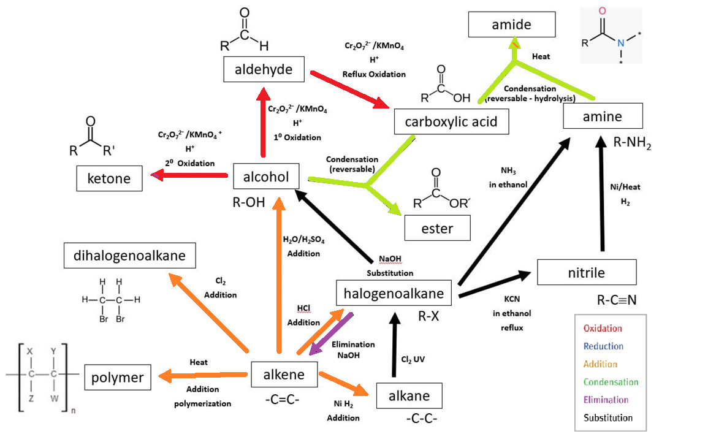

From ATAR Notes

The distinction between **class** and **functional group** should be known, e.g. for OH, hydroxyl is the functional group whereas alcohol is the class.

**Unit 4 Helpful Information**

The distinction between **class** and **functional group** should be made, e.g. for OH, hydroxyl is the functional group whereas alcohol is the class.

Conversions with more than two stages will not be assessed.

Reagents, conditions and equations should be included, e.g. the reaction of 1-bromopropane to 1-butylamine can be done in two stages: 1-bromopropane can be reacted with potassium cyanide to form butanenitrile, which can then be reduced by heating with hydrogen and a nickel catalyst to form 1-butylamine.

Students are not required to recall reaction mechanisms for substitution and elimination reactions.

Addition reactions with alkenes: reactions with $H_{2}$, ${Br}_{2}$, $H_{2}$ O and HBr (Markovnikov’s rule) should be covered.

**Summary of pathways:**



Modified from:

Brown, C and Ford, M 2009, *Chemistry*, 1st edition, Pearson Education, Marlow, Essex.

The straight chain and α-ring forms of glucose and fructose are given in the *Chemistry data booklet*.

The common names, symbol, structural formula and pH of isoelectric point for amino acids are given in the *Chemistry data booklet*.

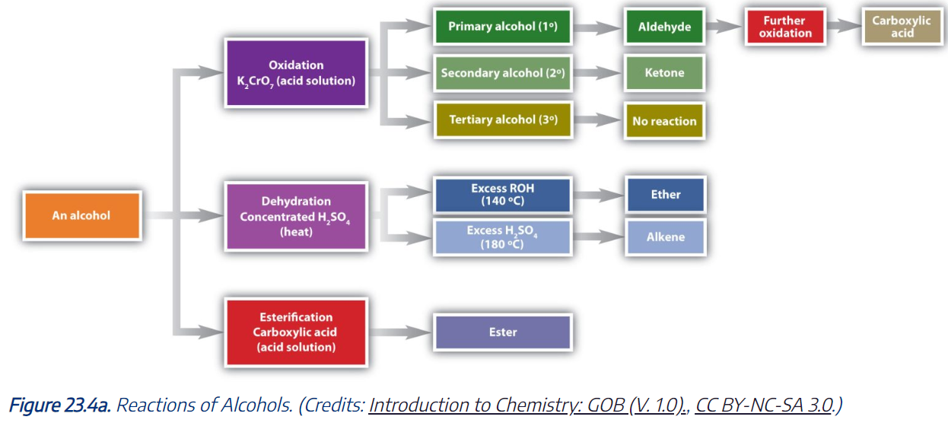

**Summary of pathways:**

From ATAR Notes

